Diana Hill
May 2, 1999
Math 232, Smith
Kernels of Matrices

Just as functions of one variable have zeros, or solutions, so do linear transformations. We would like to examine the properties of these zeros. We find that comparing them to the zeros of functions can be particularly helpful in understanding their behavior. Furthermore, we can apply the results of our findings to specific mathematical questions and real life situations. We begin by reviewing the properties of these zeros.
The “zeros” of linear transformations are given a unique name: the kernel. We define the kernel of a linear transformation as the set of all vectors that yield the zero vector. In other words, the zeros of a linear transformation T occur when 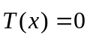. The kernel of a transformation has three important properties: one, it always contains the zero vector; two, it is closed under addition; and three, it is closed under scalar multiplication. The kernel is easily identified when the matrix of a transformation is put into reduced row echelon form. For example, consider the matrix A defined by 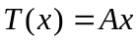. We let
A=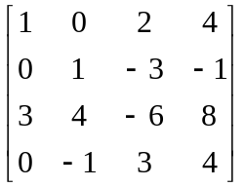 and rref (A)= 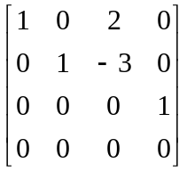.
We juxtapose this matrix with the zero vector to find its zeros:
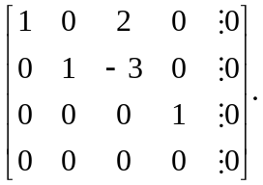
We see that if we let 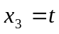then 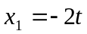, 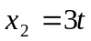, and 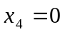. Therefore
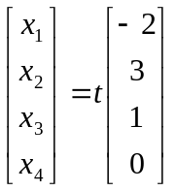 and so 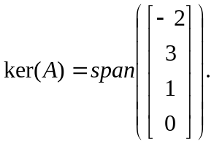
The dimension of the kernel is the number of vectors that span, so the dimension of the kernel of A is 1. Also notice that the dimension is given by the number of columns without leading ones in reduced row echelon form.
Now, to better understand these properties of kernels, we compare the zeros of a function of one variable to the kernels of matrices. Consider the possible number of zeros that a function can have: none, one, multiple or infinite. First, it is fairly simple to think of functions that have no zeros (for example 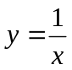). However, since the first property of kernels states that the kernel of any transformation contains the zero vector, the kernel can never be the empty set. As an example, consider a matrix B such that
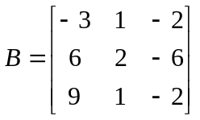 and 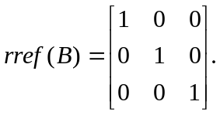
From the above discussion we know that the dimension of the kernel of this matrix is zero (because every column of rref (B) has a leading one). However, when we let 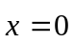 we see that
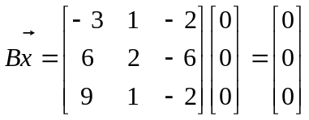
so is indeed in the kernel of B. Therefore, eventhough the dimension of the kernel of a matrix may be zero, the kernel is never the empty set.
Second, we know that functions can have a single zero (for example ). How does this compare to kernels of transformations? Since every kernel contains the zero vector, a kernel with a singular solution must be the kernel with the set containing only the zero vector. Such a matrix of a transformation will therefore be the identity matrix when put in reduced row echelon form if it is square (as seen with matrix B above,) or will have a leading one in every column if it is not square. So transformations, like functions, can have a single zero.
Third, we know that functions can have multiple zeros (for example 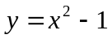). In a similar way, any matrix of a transformation whose reduced row echelon form has columns without leading ones has more than the zero vector in its kernel. In particular, if the matrix of the transformation is an n x n matrix, then the reduced row echelon form of the matrix will not be the identity matrix. This means that the matrix is not invertible. So, kernels of non-invertible matrices can contain multiple vectors as their zeros just as functions can have multiple numbers as their zeros.
Fourth, we consider functions with infinitely many zeros (for example 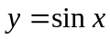). Any transformation whose kernel contains more than just the zero vector has infinitely many solutions as well. This is because of the properties of kernels, which tells us that the kernel is closed under addition and scalar multiplication. So if there is one nonzero vector in the kernel of a transformation, all vectors that are scalar multiples of this vector are also zeros. If there is more than one nonzero vector in the kernel, then all vectors that are linear combinations of these vectors are also in the kernel. In both of these cases, a linear transformation has infinitely many solutions. Therefore, any linear transformations that have multiple zeros (and specifically any transformations defined by non-invertible n x n matrices) actually have infinitely many zeros. This information is particularly helpful when examining the mathematical question that follows.
Let us consider a non-invertible n x n matrix A. Can we always find a nonzero n x n matrix B such that 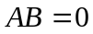? Since A is non-invertible, we know that the reduced row echelon form of A cannot be the identity matrix. As described above, this means that there must be infinitely many zeros to a linear transformation defined by . Reconsider the 4x4 matrix A used as a first example. In this case A is non-invertible. We know that the kernel has dimension one and found a zero to be the vector such that
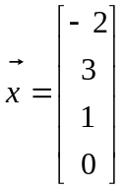. (Note that 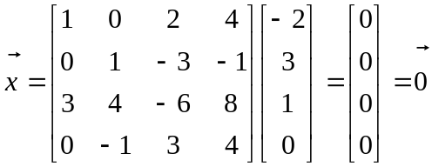
is indeed true.) Since the kernel is closed under scalar multiplication, we can build an n x n matrix B whose columns are scalar multiples of , such that AB=0. For example, let
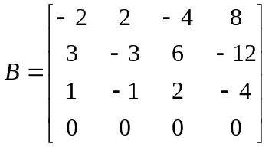, then
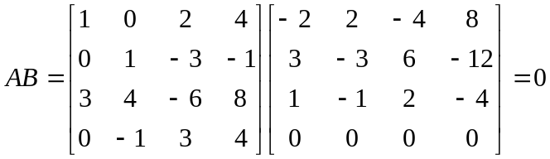.
Let us consider how this information might be used in real life. Imagine that you are a government agent of the highest rank. Your life is in danger because of your incredible genius. You decide to go into hiding in the dense forest of Argentina. You must radio your location to your country’s headquarters so that supplies may be brought to you; however you fear that your radio waves, and thus your location, could be intercepted by the enemy. You decide to encode your location using a linear transformation. Before you leave you make some necessary arrangements. You tell your highest-ranking officials that you will send them a 2x2 matrix over the radio. Your location will be found in the kernel of the matrix. However, since the kernel is closed under scalar multiplication, there would be infinitely many vectors in the kernel. Your officials could guess your location to be any of the vectors that are scalar multiples of your actual position. For this reason you tell them that you will be in northern Argentina and that you will find a location that consists of whole number longitude and latitude values so that your officials can look for a kernel of whole numbers. After making these arrangements you leave.
You journey into the woods by car and then on foot until you find a dark and secluded cave. Your compass tells you that your location is 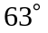 longitude, 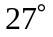 latitude. You need to find a non-invertible 2x2 matrix whose reduced row echelon form has one column without a leading one. (Recall that we just found that a non-invertible matrix is guaranteed to have at least one solution other than the zero vector.) You want to find a matrix A such that 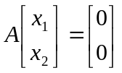 (where  is your longitude and  is your latitude) so that your top officials can determine your location by simply finding the kernel of the matrix A. You let 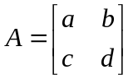 for arbitrary a, b, c, d, so that
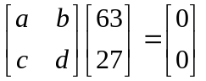 and therefore 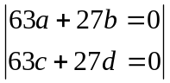 .
Any whole numbers a, b, c, d that satisfy these equations will work. You choose 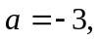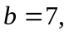 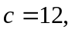 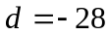. Thus A is 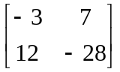. You send your signal and your trusted officials soon determine that the kernel of the matrix is 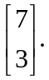 They check the whole number scalar multiples of this and find that your only possible location, or the only 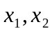 that lie in northern Argentina are 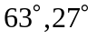. You are successfully safe and food is on its way. If you had not realized that n x n non-invertible matrices have infintely many solutions, your officials may never have been able to find you.

References

Bretscher, Otto. Linear Algebra with Applications. Upper Saddle River, New Jersey: Prentice-Hall, Inc., 1997.

